World’s Best School Prize
Social Media Toolkit

Dear Children’s Aid Team,
I hope this message finds you well!
As we continue to spread the word about the World's Best School Prize competition, I wanted to inform you that I have updated the social media toolkit for your use. The toolkit is organized into sections, allowing you to easily copy and paste captions to your preferred social media platforms with accompanying approved images. Additionally, I have included links to our previous posts, which you can reshare if you prefer, or use in addition to the contents within this document.
This toolkit was created to ensure our language and branding remain consistent across all profiles.
If you have any questions, please feel free to reach out.

Best regards,

Melissa Almonor
Social Media Manager
she, her, hers
CHILDREN’S AID
347.387.7007 (mobile)
117 W 124th Street
New York, NY 10027
Malmonor@ChildrensAidNYC.org

Direct Link to Salomé Ureña’s Voting Page
- https://canyc.info/Vote

Post Links You Can Share/Repost
- Twitter
https://x.com/ChildrensAidNYC/status/1803518514013053133
https://x.com/ChildrensAidNYC/status/1802673113601077465
https://x.com/ChildrensAidNYC/status/1801978505506242910
https://x.com/ChildrensAidNYC/status/1801748876489027941
- Instagram
https://www.instagram.com/p/C8aPJLvAZGW/?utm_source=ig_web_copy_link&igsh=MzRlODBiNWFlZA==
https://www.instagram.com/p/C8UqlAAOTnC/?utm_source=ig_web_copy_link&igsh=MzRlODBiNWFlZA==
- Facebook
https://www.facebook.com/share/p/LFZygJC7oTW2ZcZn/
- LinkedIn
Post | LinkedIn
Post | LinkedIn

New Social Media Captions for Your Use

For Leadership Only
- LinkedIn/FB Caption:
It’s an honor to be part of the Children's Aid leadership team, advocating for Salomé Ureña Leadership Academy's mission to nurture community through education. Your vote can help us win the World’s Best School Prize and continue making meaningful contributions. Vote here: https://canyc.info/Vote #Top10Finalist #EducationExcellence #VoteNow

For All CA Staff
- Photo #1
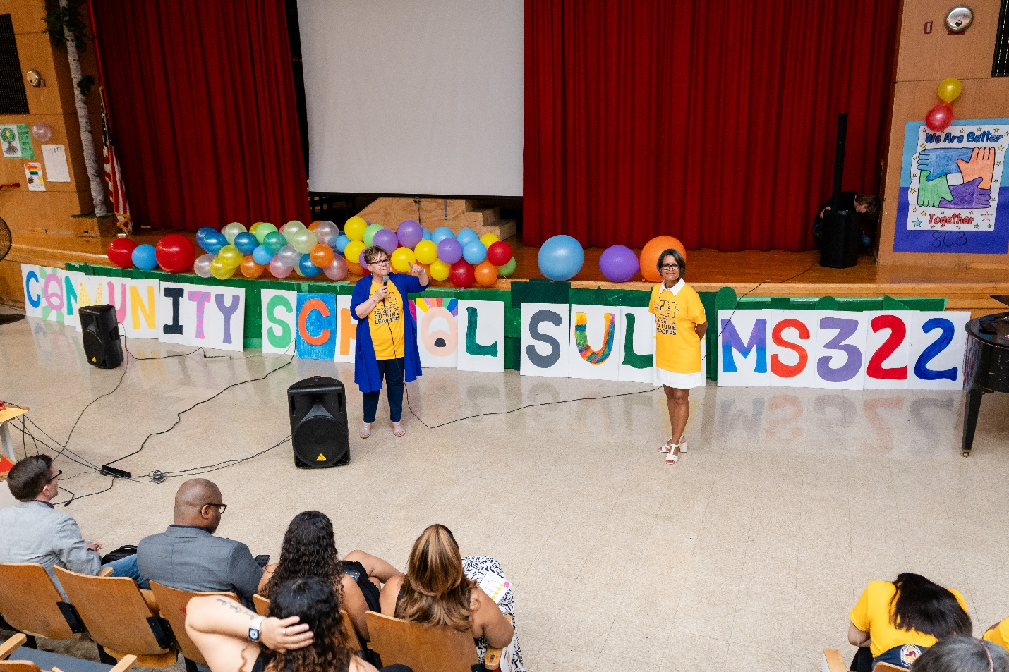
- Twitter Caption
As a Children's Aid (insert: employee, trustee, supporter), I'm proud to stand with Salomé Ureña Leadership Academy in their mission to foster community through education. Your vote can help us win the World’s Best School Prize and help us continue making a difference! Vote here: https://canyc.info/Vote

- LinkedIn/FB Caption
As a Children's Aid (insert: employee, trustee, supporter), I'm proud to stand with Salomé Ureña Leadership Academy in their mission to foster community through education. Your vote can help us win the World’s Best School Prize, and help us continue making a difference! Vote for us here: https://canyc.info/Vote #Top10Finalist #EducationExcellence #VoteNow

- IG Caption
As a Children's Aid (insert: employee, trustee, supporter), I'm proud to stand with Salomé Ureña Leadership Academy in their mission to foster community through education. Your vote can help us win the World’s Best School Prize, and help us continue making a difference! Vote through the link in my bio. #Top10Finalist #EducationExcellence #VoteNow
- Photo #2
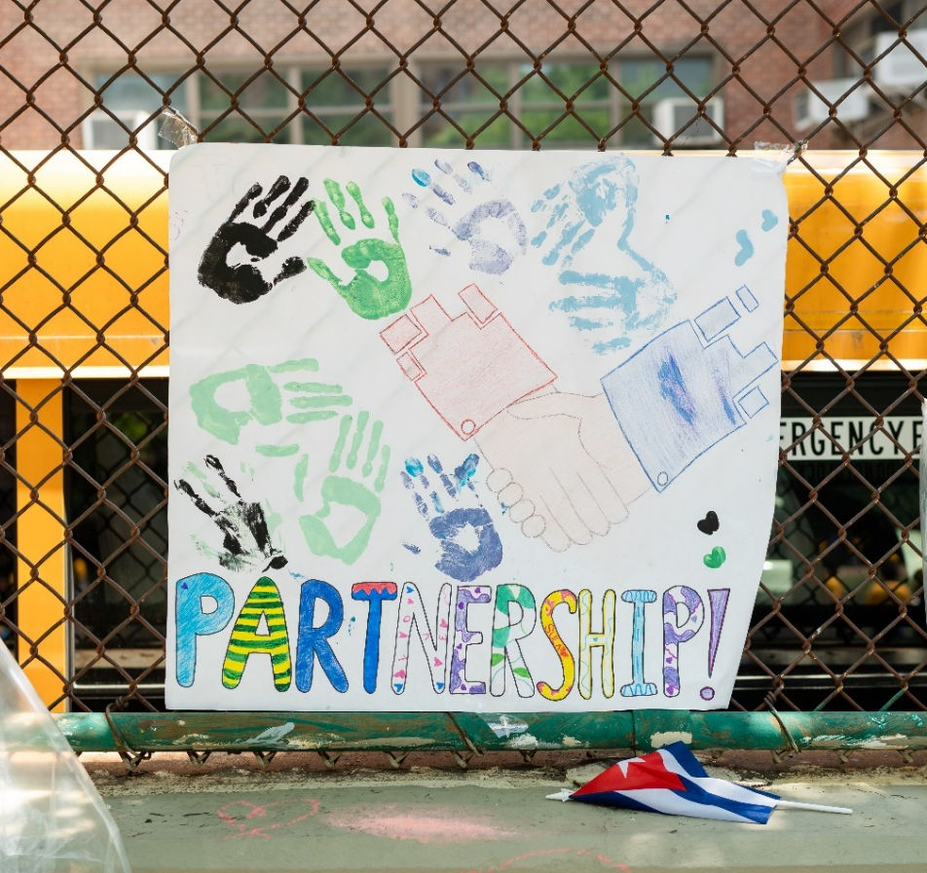
- Twitter Caption
One week to go! Support Salomé Ureña Leadership Academy MS 322 and help us empower students. Your vote is crucial for us to win the World’s Best School Prize. Vote here: https://canyc.info/Vote

- LinkedIn/FB Caption
One week to go! Support Salomé Ureña Leadership Academy MS 322 and help us continue to empower students. Your vote is crucial in helping us win the World’s Best School Prize for Community Collaboration. Cast your vote here: https://canyc.info/Vote
#Top10Finalist #EducationExcellence #VoteNow

- IG Caption
One week to go! Support Salomé Ureña Leadership Academy MS 322 and help us continue to empower students. Your vote is crucial in helping us win the World’s Best School Prize for Community Collaboration. Cast your vote through the link in my bio.
#Top10Finalist #EducationExcellence #VoteNow
Photo #3
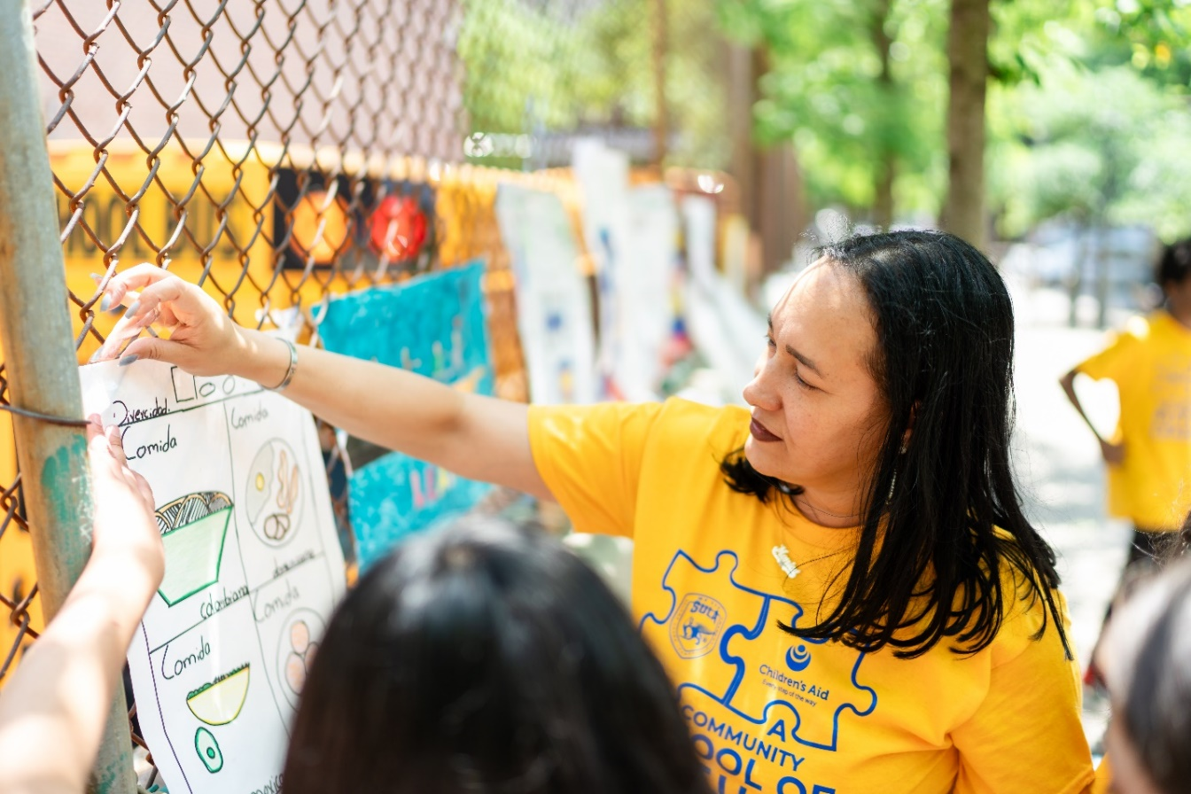

- Twitter Caption
One week remains to make a difference! Cast your vote for Salomé Ureña Leadership Academy MS 322 and help us achieve the World’s Best School Prize Award. Vote your support: https://canyc.info/Vote

- LinkedIn/FB Post
One week remains to make a difference! Cast your vote for Salomé Ureña Leadership Academy MS 322 and help us achieve the World’s Best School Prize Award for Community Collaboration. Your support can make a lasting impact on our students and community. Vote now: https://canyc.info/Vote #Top10Finalist #EducationExcellence #VoteNow

- IG Caption
One week remains to make a difference! Cast your vote for Salomé Ureña Leadership Academy MS 322 and help us achieve the World’s Best School Prize Award for Community Collaboration. Your support can make a lasting impact on our students and community. Vote now link in my bio. #Top10Finalist #EducationExcellence #VoteNow

